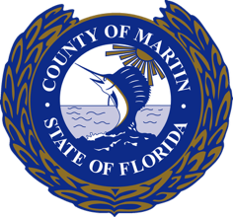
Supplemental Memorandum
Date: July 8, 2026
To: Honorable Members of the Board of County Commissioners
Via: Don G. Donaldson, P.E., County Administrator
From: Stephanie Merle, Director of the Office of Management & Budget
Reference: 26-0835

Subject: BOARD OF COUNTY COMMISSIONERS’ FISCAL YEAR 2026/2027 BUDGET WORKSHOP
Attached is the presentation for the fiscal year 2026/2027 budget workshop.

DGD/SM/dg
Attachment

